

Dog Walker Database

Final Portfolio



11/29/17

Alex Decknadel Steven Jewkes Nicholas Orr

**Table of Contents**

Ad Hoc Innovations 2

Team Member Biographies 2

Task Delegation 3

Executive Summary 4

Dog Walker Database 6

Oracle ER Diagram 16

Toad ER Diagram 17

DeZign ER Diagram 18

IDEF1X ER Diagram 19

Business Rules 20

Glossary 22

Dog Walker DDL 24

Query DML 26

# Ad Hoc Innovations



We here at Ad Hoc Innovations strive to produce quality database solutions for our clients. In the scope of this course, Ad Hoc Innovations is a small team that consists of three members working together to produce a database solution. We aim to create a database solution that is not only functional but professional and easy to use.

Our mission statement is:

*Ad Hoc Innovations aims to provide our clients with a design and development environment that fosters creativity without sacrificing efficiency.*

# Team Member Biographies



**Alex Decknadel:** Alex Decknadel is a 2ndyear CIS student at ChemeketaCommunity College. He has a background in web development, experience with Microsoft Access, and knowledge on database structures and SQL gained through the Oracle Academy.

**Steven Jewkes:** Steven Jewkes is a 2ndyear CIS student at ChemeketaCommunity College. He is proficient in Microsoft Office, has experience in HTML, JavaScript, CSS, PHP, and Visual Basic, and primarily has worked on hardware systems implementation and repair for over 10 years.

**Nicholas Orr:** Nicholas Orr is a 2ndyear CIS student at Chemeketa CommunityCollege. He has two years professional experience with troubleshooting software and hardware issues in Windows, is familiar with HTML, CSS3, and basic programming concepts such as loops, tables, and variables.

MILESTONE 6 – NOVEMBER 2017 2

# Task Delegation



**Alex Decknadel:** This member was responsible for designing the logical modelthrough the Toad Data Modeler, and creating the DDL used to generate the database in Access and the queries, forms, and reports used to retrieve and store data in the database. He also worked on the conceptual design and its refinement as well as write the description of the database for this portfolio.

**Steven Jewkes:** This member was responsible for designing the logical modelthrough the DeZign Data Modeler program. He also designed the forms and reports in the working database to be identical, and contributed to the conceptual design and its refinement through the various ERD programs and transition between conceptual to logical to the physical.

**Nicholas Orr:** This member was responsible for designing the conceptualmodel through the Oracle Data Modeler and the conversion of the logical model into IDEF1X format. He also contributed to the conceptual design and refinement process, collaboration of the business rules and glossary. This member was also responsible for designing and implementing the Switchboard form used to navigate the database and the User Manual which describes how to use that Switchboard.

MILESTONE 6 – NOVEMBER 2017 3

# Executive Summary



This portfolio showcases the “Take Me Out” database. “Take Me Out” is a database designed for a dog-walking app that allows people to find walkers and schedule for their dogs to be taken on walks for a fee.

The app captures a customer’s information, their dog’s information and a scheduled time for their walk. There are certain business rules that the database conforms to, such as walkers needing to be insured and bonded before they can begin working and receiving pay. Eventually, the app will include GPS functionality. However, this will not be implemented until after the prototype database is completed.

The database itself is relatively small, consisting of only four relations. We have one for the customers, one for employees, one for dogs, and one for schedules. It provides relatively simple ways to select and break down data.

This portfolio details the development of “Take Me Out.” The portfolio includes a conceptual model that consisted of six tables; separate tables were made for customer information, employee information, dog information, scheduling, behavior notes and transactions. We were able to refine the conceptual design to fold both the scheduling and behavior notes tables into a single entity called Appointment.

Because transactions would not be necessary for the prototype database and would be something included in later iterations, we removed the Transaction entity entirely, leaving our final design with four entities, Customer, Dog, Employee and Appointment.

During the course of the design process, we converted our model into a logical model which was then refined into a physical model. This portfolio includes the different Entity-Relationship diagrams designed for our data model, and the business rules that were considered in designing the data model.

MILESTONE 6 – NOVEMBER 2017 4



These queries should include information on which walkers are uninsured, which customers request the most walking time for their dogs, money earned by the walkers, a walker’s availability, which walkers will walk old dogs and which ones can walk large dogs, as well as other data.

We also discovered that customers should be able to see which walkers spend the most time with their dogs simply by providing a dog’s name.

Included in this report is a comprehensive breakdown of the database as well as the design process we utilized throughout this project. The breakdown includes screenshots of the data models and the data model programs we utilized to create them. We also provide the most recently discussed list of business rules that can be modeled or programmed from what we obtained through meetings with the founders.

At the end of the portfolio, we include the most recent glossary that reflects terms used to describe the database, the DDL we used to construct the structure of the database, the DML for the queries we created to retrieve data from the database, and a user manual for how to use the database’s switchboard to access reports and forms as well as enter in data.

|  |  |
| --- | --- |
| MILESTONE 6 – NOVEMBER 2017 | 5 |

# Dog Walker Database



The “Take Me Out” database is a database for an upstart dog walking business. The goal is to have a functional database that collects information about customers, walkers, dogs, and appointments. The database uses this data to generate information regarding how many hours each walker walks and how many times a customer schedules a walk for their dog(s).

In the database, we have four relations (tables or entities) that make up the database structure at this time. They are: CUSTOMER, EMPLOYEE, DOG, and APPOINTMENT. Each relation has a set of attributes (columns) that describe each one, as listed in the following.

CUSTOMER (Customer ID1, First Name, Last Name, Credit Card Number, Street Address, City, State, Zip Code, Email Address, Phone Number, Lockbox)

EMPLOYEE (Employee ID, First Name, Last Name, Phone Number, Email Address, Insured and Bonded, Hire Date, Rate of Pay, Availability, Old Dogs, Large Dogs)

DOG (Dog ID, Name, Customer Name, Weight, Breed, Gender, Age, Social, Special Needs)

SCHEDULE (Schedule Number, Employee ID, Customer ID, Dog ID, Date, Start of Walk, End of Walk)

To retrieve this data, we created queries and reports to organize data into information. We also created forms to organize data as well as store data inside the database.

The first form we created was the Customers form, with a subform called Appointments. The Customers form displays attributes of the CUSTOMER relation. This form also displays the Appointments subform, allowing users to enter a scheduled walk into the APPOINTMENT relation. The form is shown below.

1. Underlined attributes are primary keys for each relation, meaning this value is unique to each tuple (row).

MILESTONE 6 – NOVEMBER 2017 6

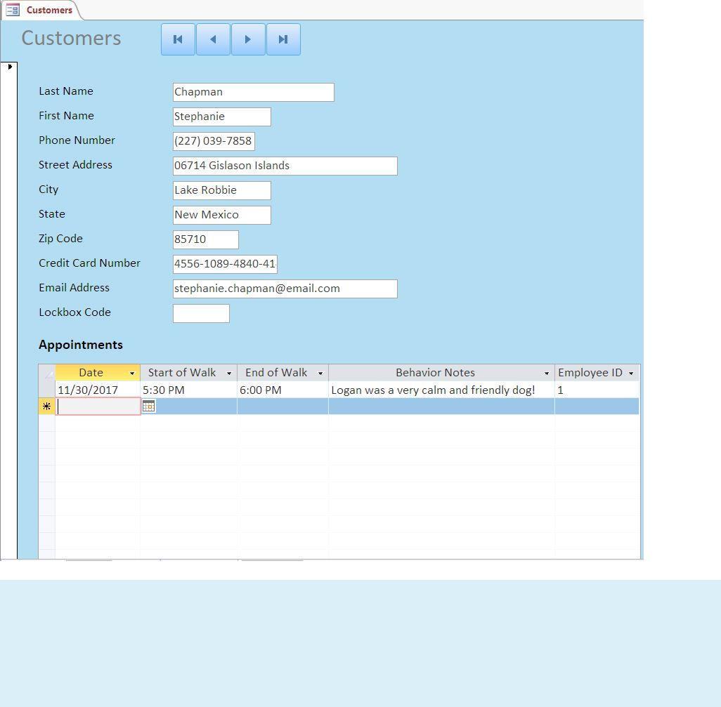

After these were created, we created a form called Dogs. This form allows users to add dogs into the database. This is also used a subform for Dog Owners, where users can add customers and dogs as seen in the following screenshots.

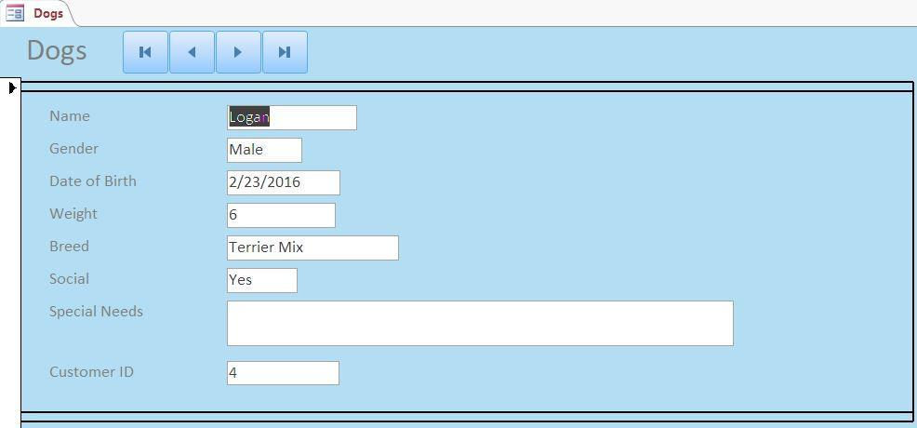

|  |  |
| --- | --- |
| MILESTONE 6 – NOVEMBER 2017 | 7 |

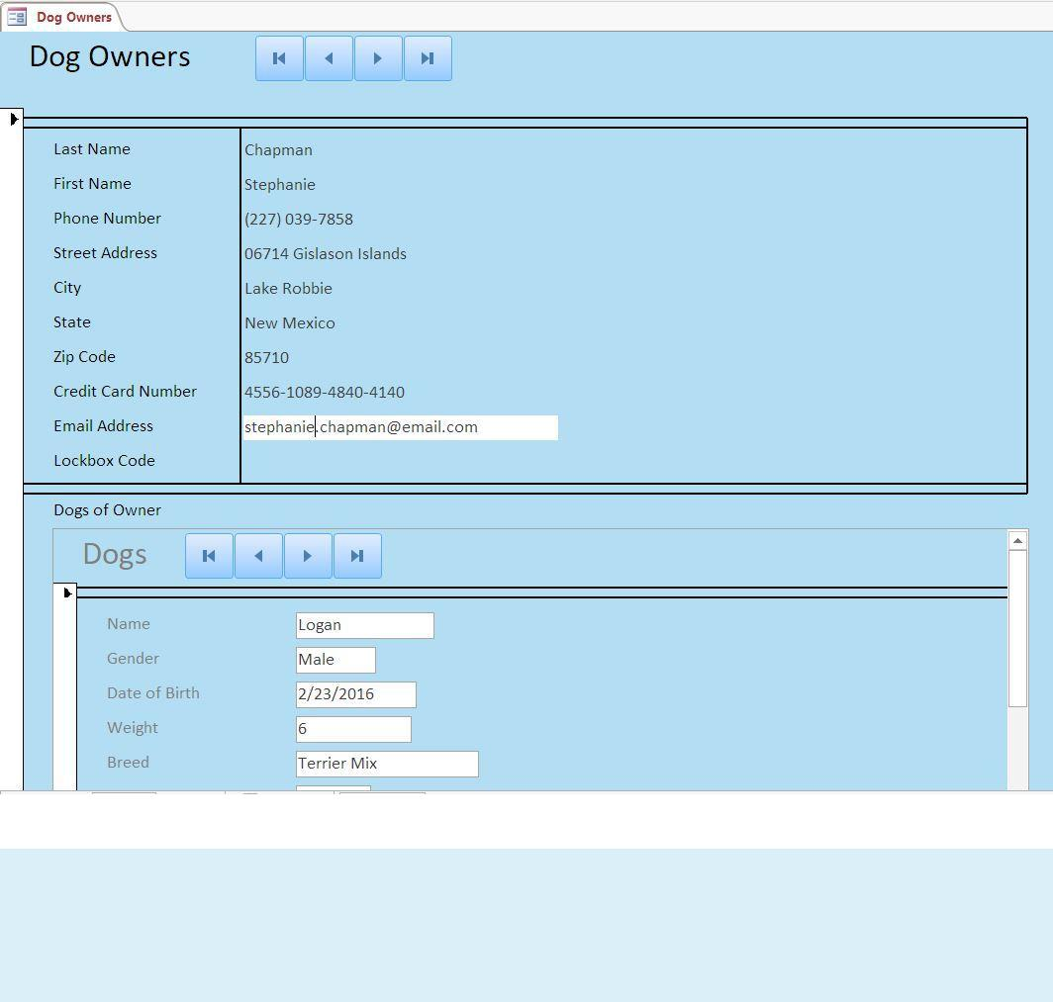

After these forms were created, we created the Employees form. This form displays information about each walker and allows users to add more walkers into the database. We show this form in the following screenshot.

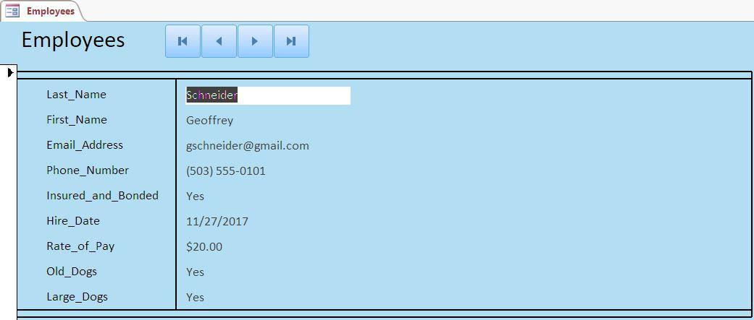

|  |  |
| --- | --- |
| MILESTONE 6 – NOVEMBER 2017 | 8 |

After the forms were created, we wrote some queries that would retrieve data and generate information for us.

These queries are:

Best Customers

Money Earned by Walkers Specific Walker Schedule Walkers

Walkers and Times by Dog Walkers of Big Dogs

Walkers of Old Dogs

Walkers who are not Insured

Starting at the top, the Best Customers query generates information about how much total time each customer schedules over all of the walks they’ve scheduled. This is shown in the following screenshot.

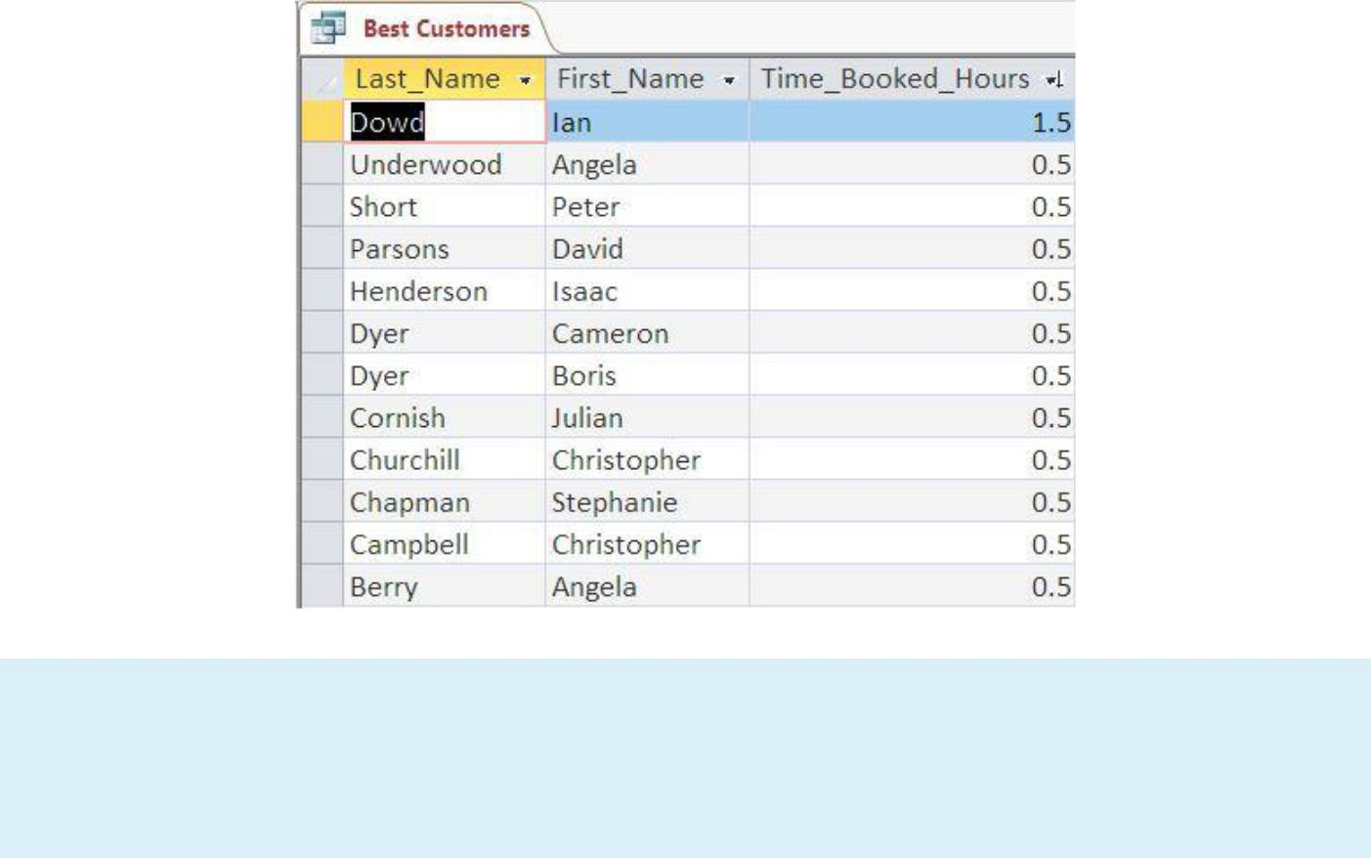

The next query, Money Earned by Walkers, generates information about how much money each walker earns based off how much time they walk. This is shown below.

MILESTONE 6 – NOVEMBER 2017 9

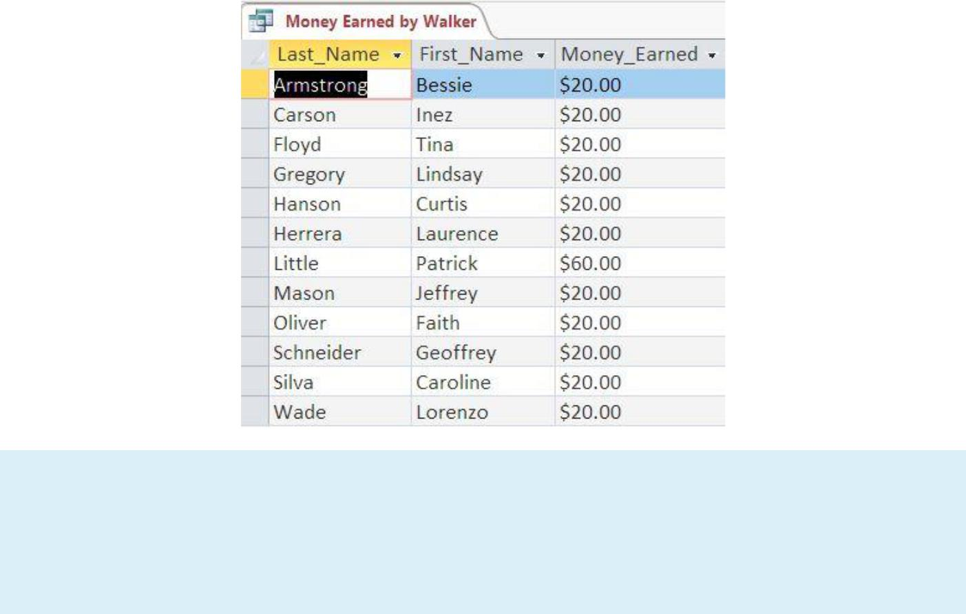

Specific Walker Schedule is query that allows users to enter in an Employee’s name to see the walks they have scheduled. We can see below the parameter that asks users to enter in an employee’s last name and what is generated from entering Schneider, the last name of a walker.

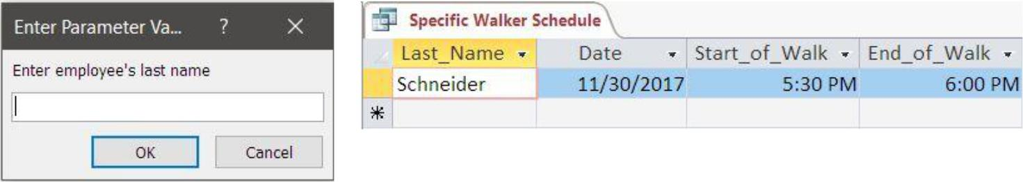

The Walkers query is a query we created to use for creating the Walker’s Report. Because we wanted to track the total time each walker has walked across all of the walks they’ve attended, we needed to calculate a field to put into the report. And this is best done through a query first, which we can then put into the report. Both the query and the report are shown below.

|  |  |
| --- | --- |
| MILESTONE 6 – NOVEMBER 2017 | 10 |

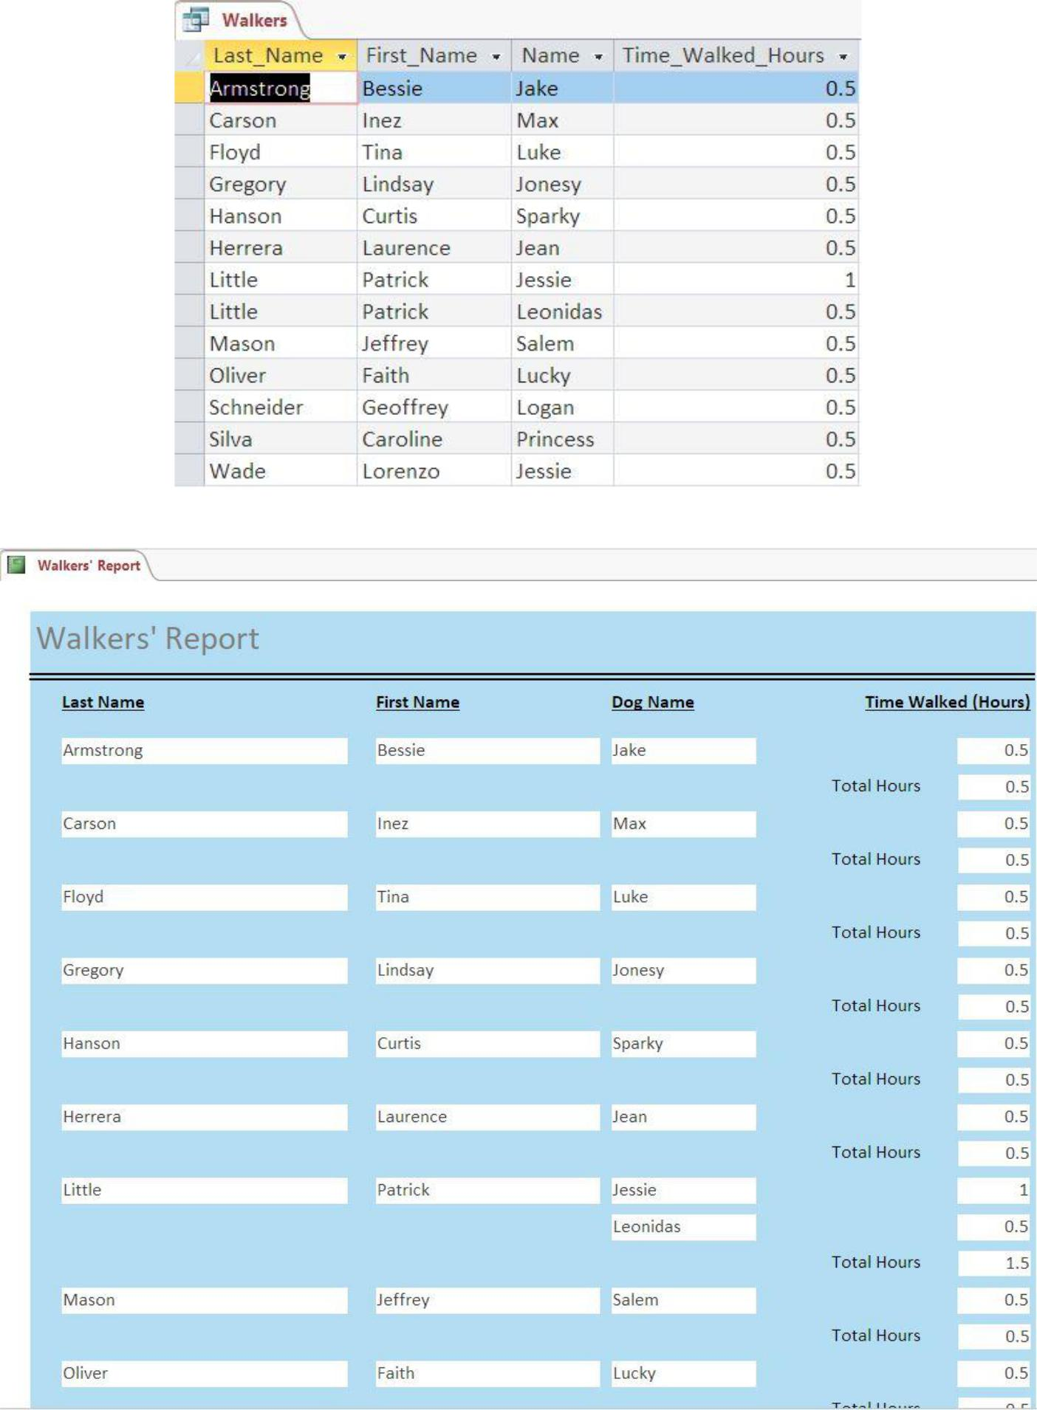

|  |  |
| --- | --- |
| MILESTONE 6 – NOVEMBER 2017 | 11 |

Moving on, the Walkers and Times by Dog query has a parameter that allows users to search which dog has been walked by who. The following shows the parameter that allows users to enter in a dog’s name and the query generated from entering the name Jessie.

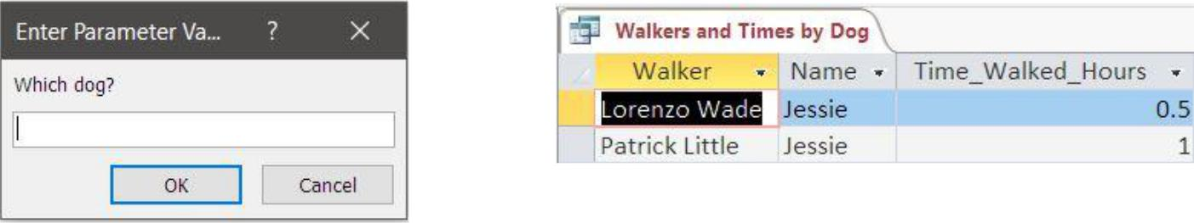

The Walkers of Big Dogs query is a query that generates a list of walkers who have walked dogs that weigh over 60 pounds. We show this in the following screenshot.

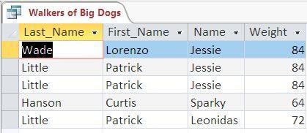

The last query, Walkers of Old Dogs, is a query that creates a list of walkers who walk dogs that are over 8 years old. The query is shown below.

MILESTONE 6 – NOVEMBER 2017 12

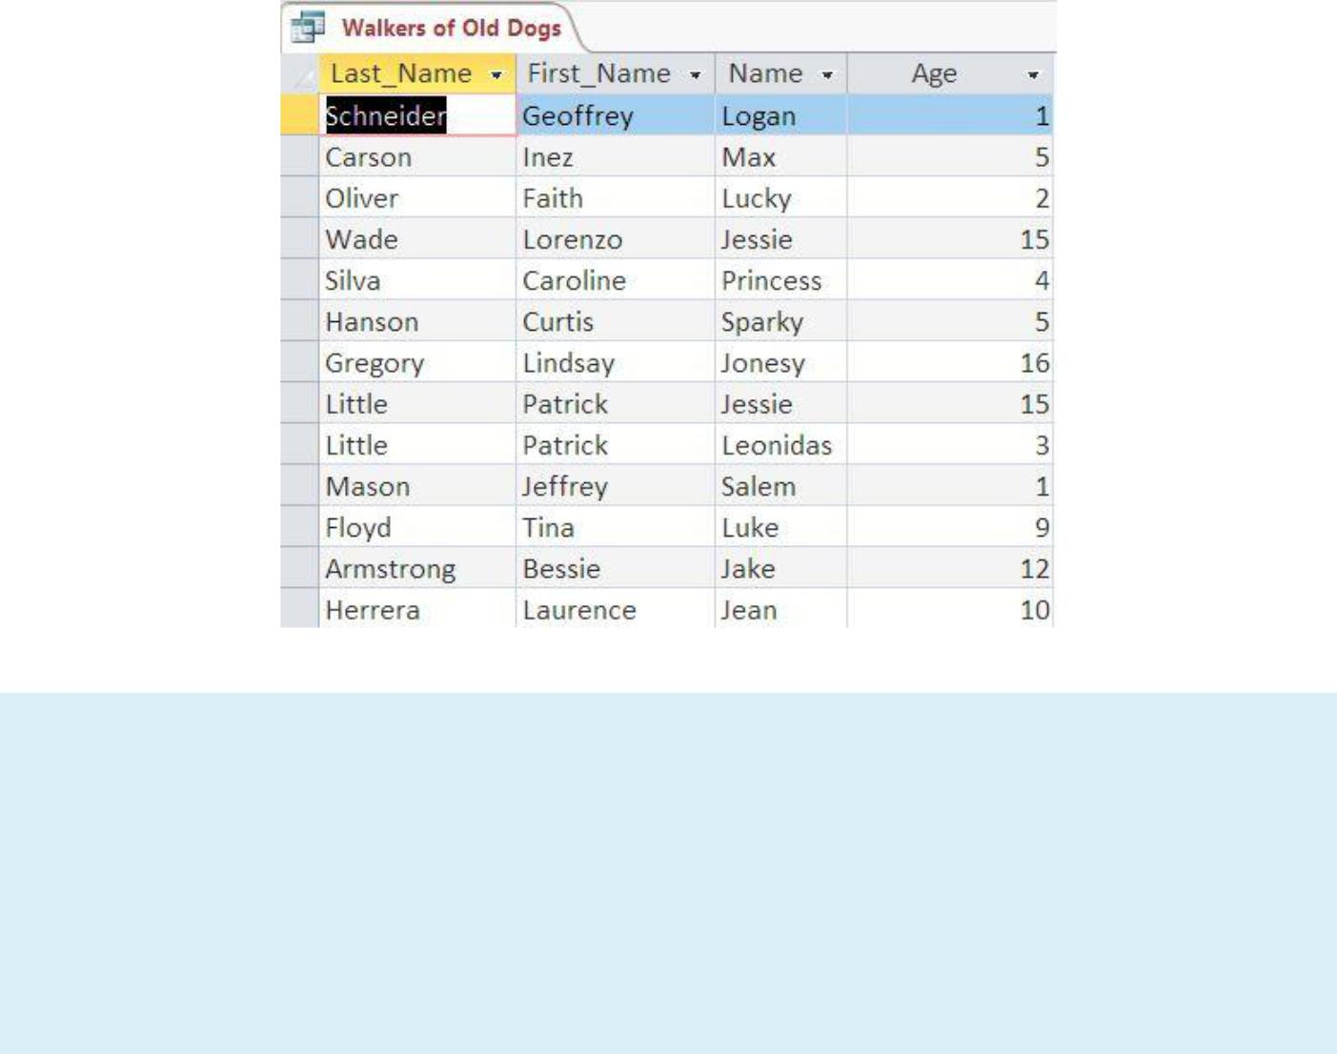

Moving onto the rest of the reports, these organize information about which walkers are uninsured, which walkers walk large dogs, and which walkers walk old dogs.

The Dog Chow report is the report that shows which walkers walk large dogs and which large dogs they walk. The following image shows the report based off the current data in the Take Me Out database.

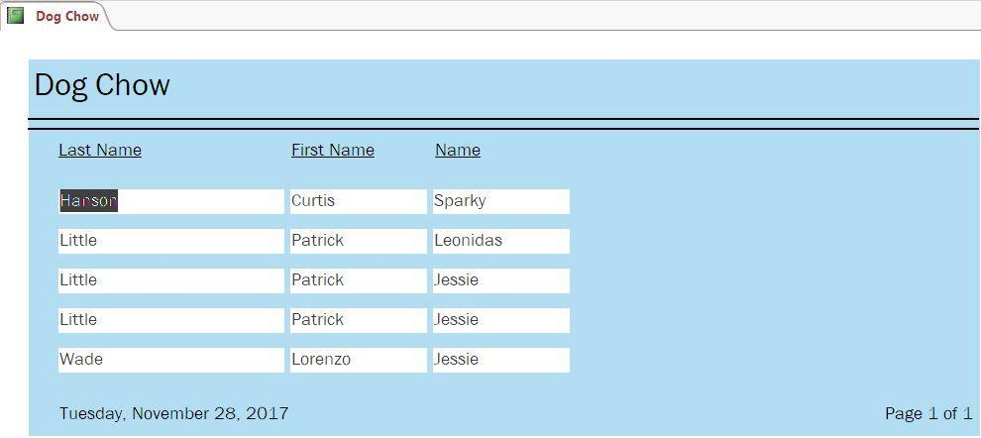

|  |  |
| --- | --- |
| MILESTONE 6 – NOVEMBER 2017 | 13 |

Dog Days is the report that shows which walkers walk old dogs and which old dogs they walk. The following image shows the report based on the current data inside the database.

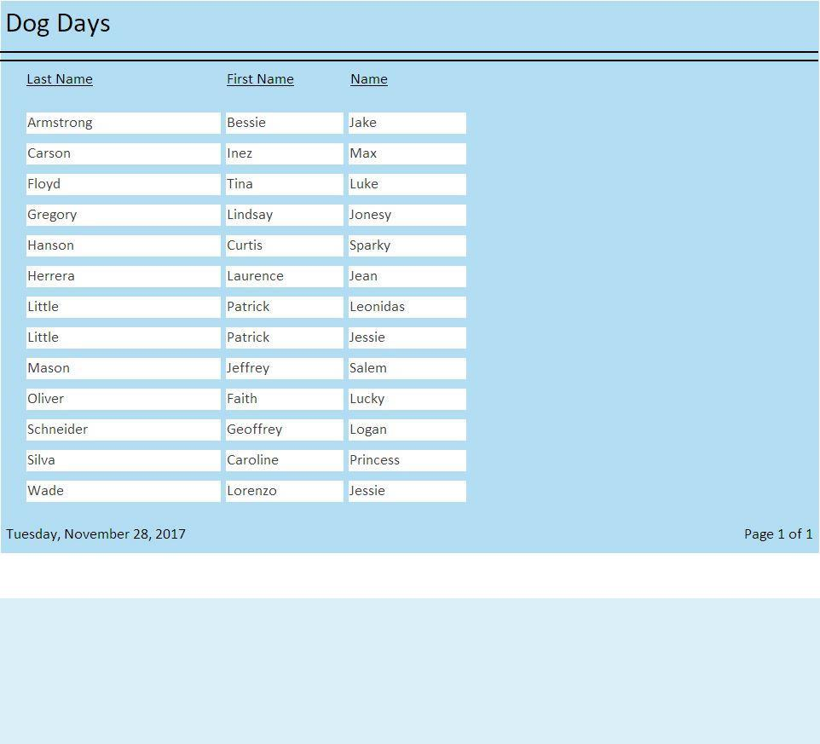

The last report, Uninsured Walkers, is the report that tracks the walkers who are not yet insured and bonded. It is useful for business owners to keep track of these walkers as they need to be insured and bonded so they can be paid. The following image shows a report from the current data.

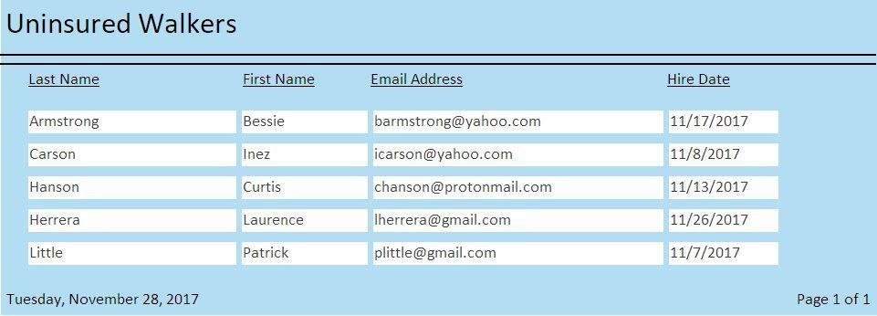

MILESTONE 6 – NOVEMBER 2017 14

After all of those were created, Ad Hoc Innovations worked on a switchboard that users could use to easily navigate to these forms and reports to add data or pull information from the database. The following image is a screenshot of the switchboard we designed for the Take Me Out database.

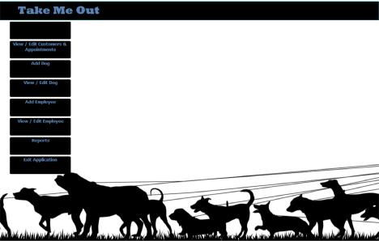

MILESTONE 6 – NOVEMBER 2017 15

# Oracle ER Diagram



This ER diagram is a conceptual model designed through Oracle Data Modeler from Oracle. It uses Crow’s foot notation. This is the first ER Diagram that Ad Hoc Innovations designed during the design stages.

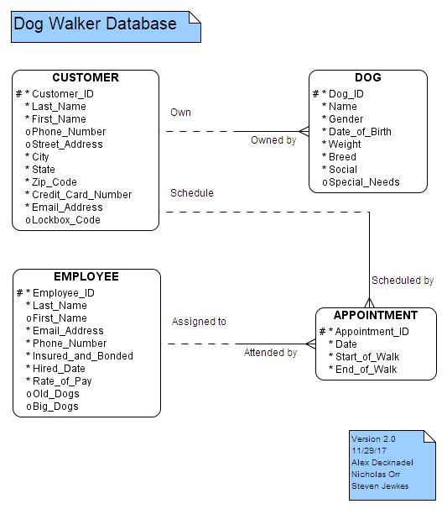

MILESTONE 6 – NOVEMBER 2017 16

# Toad ER Diagram



This diagram is the first logical model that was designed with Toad Data Modeler from Quest Software. It uses Crow’s foot notation. This is the second ER Diagram that Ad Hoc Innovations designed.

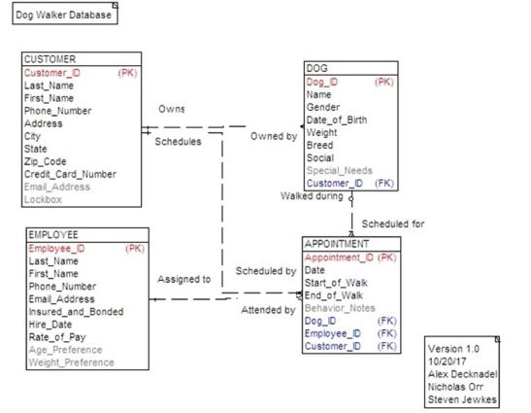

MILESTONE 6 – NOVEMBER 2017 17

# DeZign ER Diagram



The third ER Diagram for the Dog Walker database is another logical model designed with DeZign for Databases from Datanamic. It also uses Crow’s foot notation.

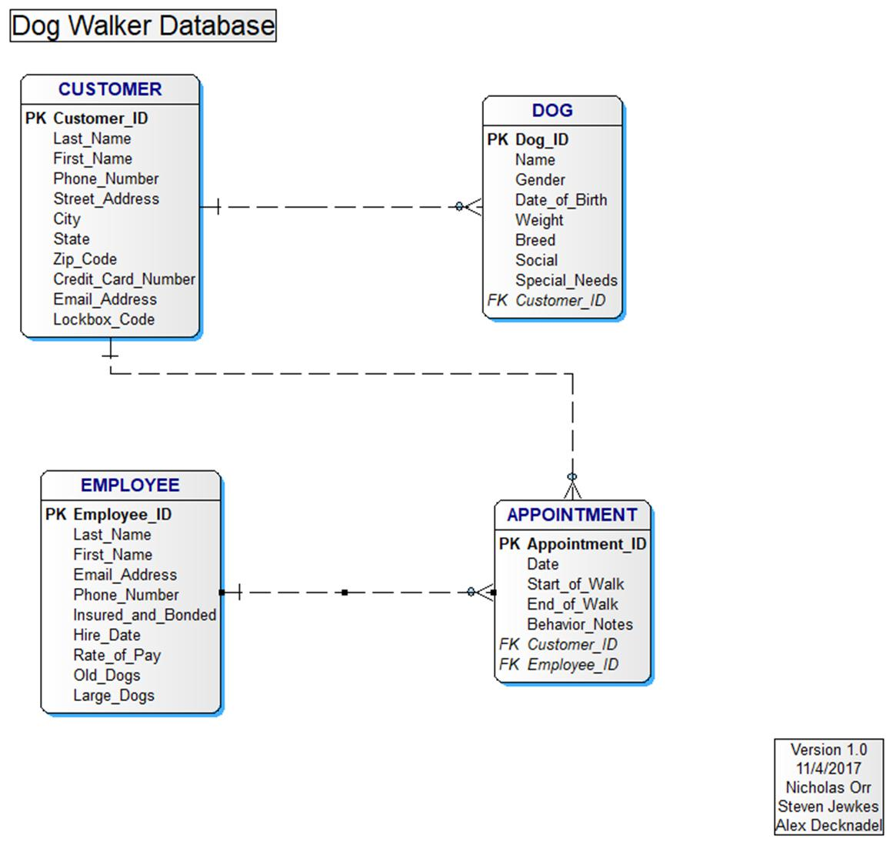

MILESTONE 6 – NOVEMBER 2017 18

# IDEF1X ER Diagram



The fourth diagram in this portfolio is a logical model using the IDEF1X notation.

It was designed using DeZign, like the previous diagram.

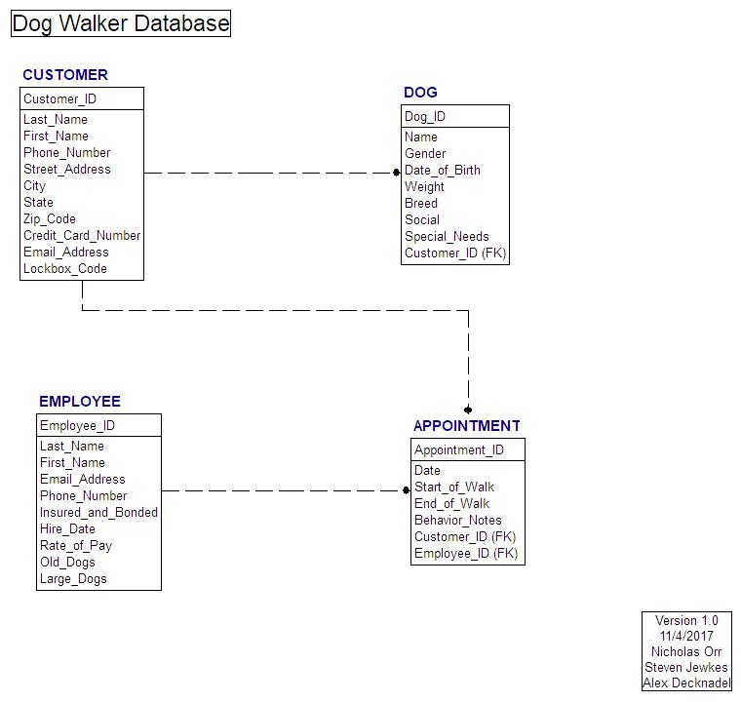

MILESTONE 6 – NOVEMBER 2017 19

# Business Rules



1. Customers must request their walk no later than one hour before the scheduled time.
2. No customer can request walks between 10:00 PM and 5:00 AM (PST).
3. A customer may own multiple dogs, but each dog must be owned by a single customer.
4. Dog walkers who are insured and bonded earn twenty dollars every half-hour.
5. A customer may have a preferred dog walker and can check if the dog walker is available for the time they want their dog walked. If the dog walker is available, then the customer can request them to walk their dog(s).
6. All customers must provide up-to-date payment information when registering, including first name, last name, complete address and credit card number, as well as a phone number and valid email address.
7. Dog walkers must provide contact information when requesting employment, including first name, last name, phone number and email address.
8. Customers must provide information about their dogs; such details include name, age, weight, breed, and gender. They may also provide any special provisions their dogs might need.
9. All dog walkers must be Insured & Bonded before they can accept appointments. Customers may request a list that shows which walkers are or are not Insured & Bonded.
10. Investors should be able to monitor how much each dog walker earns, as well as how much the company earns, given a range of time.
11. Customers may have a lockbox that provides entry to their home and if so, must provide a PIN. If they live in an apartment that has a doorman, a lockbox is not needed.
12. The app will have a GPS function that will track dog walkers on their walks. These can be viewed by customers to see where dog walkers take their dogs on walks.

MILESTONE 6 – NOVEMBER 2017 20

1. Customers may set up routine walks for their dogs. Should a customer wish to cancel routine walks, they must do so at least 24 hours prior to the next routine walk to avoid being charged.
2. Investors should be able to retrieve a list of customers who frequently use the service for their dogs.
3. Dog walkers must provide a report about each dog’s behavior after each walk.
4. Customers can call in and ask for information about how many hours each dog walker spends with their dog by providing their dog’s name.
5. Dog walkers must indicate whether they are willing to walk older dogs (dogs that are at least 8 years old) and larger dogs (dogs that weigh at least 60 lbs).

MILESTONE 6 – NOVEMBER 2017 21

22

# Glossary



**Appointment:** A date and time to walk a dog, requested bythe customer.

**Appointment_ID:** A unique numeric identifier for anappointment.

**Availability:** The dates and times in which an individualemployee is available to work.

**Behavior_Notes:** A brief record about a dog’s behavior duringa walk.

**Breed:** A specific subgroup within the dog species that definescertain characteristics about that subgroup.

**City:** A defined geographical location within a state.

**Credit_Card_Number:** The unique account number for anygiven credit card.

**Customer:** A person who requires dog-walking services.

**Customer_ID:** A unique numeric identifier for a customer.

**Date:** The day of a month or year, identified by a number.

**Date of Birth (DOB):** The day, month and year a specific dogwas born; formatted as day/month/year.

**Dog:** The pet that needs to be walked.

**Dog_ID:** A unique numeric identifier for each dog to be walked.

**Email_Address:** An email address for either a customer or anemployee.

**Employee:** A company associate who is paid to walk dogs.

**Employee_ID:** A unique numeric identifier for each employee.

**End_of_Walk:** The time when a walk ends.

**First_Name:** A first or given name for a person.

**Gender:** The sex of a dog.

MILESTONE 6 – NOVEMBER 2017 23

**Hire_Date:** The date that an employee begins working for thecompany.

**Insured_and_Bonded:** Certifications obtained by anemployee in order to protect the company from certain financial concerns, such as injury on the job.

**Large_Dogs:** A dog to be walked that weighs 60lbs or more.

**Last_Name:** The second or surname of a person.

**Lockbox:** A small, secure container used to store a key to aperson’s home or apartment.

**Old_Dogs:** A dog to be walked that is 8 years of age or older.

**Phone_Number:** A generally unique string of ten numeric digitsused to initiate communication between customers and employees.

**Rate_of_Pay:** How much an employee is paid to walk dogs; inthis case, that rate is $20 per half hour of service.

**Social:** The state of a dog regarding interaction with other dogsor persons.

**Special_Needs:** A unique circumstance(s) in which specialattention or protocol is required to successfully walk a dog.

**Start_of_Walk:** The time when a walk begins.

**State:** A defined geographical region within a country.

**Street Address:** The numeric location of a public or privateroad within a town or city.

**Weight:** A measurement to determine how heavy a dog is, it isrecorded as the number of pounds (lbs.).

**Zip_Code:** A five-digit number assigned to a geographicallocation in order to assist with the delivery of mail.

MILESTONE 6 – NOVEMBER 2017 24

# Dog Walker DDL



CREATE TABLE [CUSTOMER] (

[Customer_ID] INTEGER NOT NULL,

[Last_Name] VARCHAR(25) NOT NULL,

[First_Name] VARCHAR(15) NOT NULL,

[Phone_Number] VARCHAR(10) NOT NULL,

[Street_Address] VARCHAR(35) NOT NULL,

[City] VARCHAR(15) NOT NULL,

[State] VARCHAR(15) NOT NULL,

[Zip_Code] VARCHAR(5) NOT NULL,

[Credit_Card_Number] VARCHAR(16) NOT NULL,

[Email_Address] VARCHAR(35),

[Lockbox_Code] VARCHAR(6),

CONSTRAINT [PK_CUSTOMER] PRIMARY KEY ([Customer_ID])

);

CREATE TABLE [EMPLOYEE] (

[Employee_ID] INTEGER NOT NULL,

[Last_Name] VARCHAR(25) NOT NULL,

[First_Name] VARCHAR(15) NOT NULL,

[Email_Address] VARCHAR(35) NOT NULL,

[Phone_Number] VARCHAR(10) NOT NULL,

[Insured_and_Bonded] YESNO NOT NULL,

[Hire_Date] DATE NOT NULL,

[Rate_of_Pay] DECIMAL NOT NULL,

[Old_Dogs] YESNO,

[Large_Dogs] YESNO,

CONSTRAINT [PK_EMPLOYEE] PRIMARY KEY ([Employee_ID])

);

CREATE TABLE [DOG] (

[Dog_ID] INTEGER NOT NULL,

[Name] VARCHAR(15) NOT NULL,

[Gender] VARCHAR(6) NOT NULL,

[Date_of_Birth] DATE NOT NULL,

[Weight] INTEGER NOT NULL,

[Breed] VARCHAR(20) NOT NULL,

[Social] YESNO NOT NULL,

[Special_Needs] TEXT,

[Customer_ID] INTEGER NOT NULL,

CONSTRAINT [PK_DOG] PRIMARY KEY ([Dog_ID]), CONSTRAINT [Customer_Dog]

FOREIGN KEY ([Customer_ID]) REFERENCES [CUSTOMER]

([Customer_ID])

);

MILESTONE 6 – NOVEMBER 2017 25

CREATE TABLE [APPOINTMENT] (

[Appointment_ID] INTEGER NOT NULL,

[Date] DATE NOT NULL,

[Start_of_Walk] TIME NOT NULL,

[End_of_Walk] TIME NOT NULL,

[Behavior_Notes] TEXT,

[Customer_ID] INTEGER NOT NULL,

[Employee_ID] INTEGER NOT NULL,

CONSTRAINT [PK_APPOINTMENT] PRIMARY KEY ([Appointment_ID]), CONSTRAINT [Customer_Appointment]

FOREIGN KEY ([Customer_ID]) REFERENCES [CUSTOMER] ([Customer_ID]),

CONSTRAINT [Employee_Appointment]

FOREIGN KEY ([Employee_ID]) REFERENCES [EMPLOYEE]

([Employee_ID])

);

|  |  |
| --- | --- |
| MILESTONE 6 – NOVEMBER 2017 | 26 |

# Query DML



-- This creates the Best Customers query

SELECT CUSTOMER.Last_Name, CUSTOMER.First_Name, Sum(FormatNumber(DateDiff("n",[APPOINTMENT].[Start_of_Walk],[APPOINTMEN T].[End_of_Walk])/60)) AS Time_Booked_Hours

FROM CUSTOMER INNER JOIN APPOINTMENT ON CUSTOMER.Customer_ID = APPOINTMENT.Customer_ID

GROUP BY CUSTOMER.Last_Name, CUSTOMER.First_Name;

-- This creates the Money Earned by Walkers query

SELECT EMPLOYEE.Last_Name, EMPLOYEE.First_Name, FormatCurrency(20*Sum(FormatNumber(DateDiff("n",[APPOINTMENT].[Start_of_ Walk],[APPOINTMENT].[End_of_Walk])/30))) AS Money_Earned

FROM EMPLOYEE INNER JOIN ((CUSTOMER INNER JOIN APPOINTMENT ON CUSTOMER.Customer_ID = APPOINTMENT.Customer_ID) INNER JOIN DOG ON CUSTOMER.Customer_ID = DOG.Customer_ID) ON EMPLOYEE.Employee_ID = APPOINTMENT.Employee_ID

GROUP BY EMPLOYEE.Last_Name, EMPLOYEE.First_Name;

-- This creates the Specific Walker Schedule query

SELECT EMPLOYEE.Last_Name, APPOINTMENT.Date, APPOINTMENT.Start_of_Walk, APPOINTMENT.End_of_Walk

FROM EMPLOYEE INNER JOIN APPOINTMENT ON EMPLOYEE.[Employee_ID] = APPOINTMENT.[Employee_ID]

WHERE (((EMPLOYEE.Last_Name)=[Enter employee's last name]));

-- This creates the Walkers query

SELECT EMPLOYEE.Last_Name, EMPLOYEE.First_Name, DOG.Name, Sum(FormatNumber(DateDiff("n",[APPOINTMENT].[Start_of_Walk],[APPOINTMEN T].[End_of_Walk])/60)) AS Time_Walked_Hours

FROM (CUSTOMER INNER JOIN (EMPLOYEE INNER JOIN APPOINTMENT ON EMPLOYEE.[Employee_ID] = APPOINTMENT.[Employee_ID]) ON CUSTOMER.[Customer_ID] = APPOINTMENT.[Customer_ID]) INNER JOIN DOG ON CUSTOMER.[Customer_ID] = DOG.[Customer_ID]

MILESTONE 6 – NOVEMBER 2017 27

GROUP BY EMPLOYEE.Last_Name, EMPLOYEE.First_Name, DOG.Name;



-- This creates the Walkers and Times by Dog query

SELECT [EMPLOYEE].[First_Name]+" "+[EMPLOYEE].[Last_Name] AS Walker,

DOG.Name,

Sum(FormatNumber(DateDiff("n",[APPOINTMENT].[Start_of_Walk],[APPOINTMEN

T].[End_of_Walk])/60)) AS Time_Walked_Hours

FROM (CUSTOMER INNER JOIN (EMPLOYEE INNER JOIN APPOINTMENT ON EMPLOYEE.[Employee_ID] = APPOINTMENT.[Employee_ID]) ON CUSTOMER.[Customer_ID] = APPOINTMENT.[Customer_ID]) INNER JOIN DOG ON CUSTOMER.[Customer_ID] = DOG.[Customer_ID]

GROUP BY [EMPLOYEE].[First_Name]+" "+[EMPLOYEE].[Last_Name], DOG.Name HAVING (((DOG.Name)=[Which dog?]));

-- This creates the Walkers of Big Dogs query

SELECT DISTINCTROW EMPLOYEE.Last_Name, EMPLOYEE.First_Name, DOG.Name, DOG.Weight

FROM (CUSTOMER INNER JOIN (EMPLOYEE INNER JOIN APPOINTMENT ON EMPLOYEE.[Employee_ID] = APPOINTMENT.[Employee_ID]) ON CUSTOMER.[Customer_ID] = APPOINTMENT.[Customer_ID]) INNER JOIN DOG ON CUSTOMER.[Customer_ID] = DOG.[Customer_ID]

WHERE (((DOG.Weight)>=60));

-- This creates the Walkers of Old Dogs query

SELECT DISTINCTROW EMPLOYEE.Last_Name, EMPLOYEE.First_Name, DOG.Name, CInt(DateDiff("yyyy",[DOG].[Date_of_Birth],Date())) AS Age

FROM (CUSTOMER INNER JOIN (EMPLOYEE INNER JOIN APPOINTMENT ON EMPLOYEE.[Employee_ID] = APPOINTMENT.[Employee_ID]) ON CUSTOMER.[Customer_ID] = APPOINTMENT.[Customer_ID]) INNER JOIN DOG ON CUSTOMER.[Customer_ID] = DOG.[Customer_ID]

WHERE (((CInt(DateDiff("yyyy",[DOG].[Date_of_Birth],Date())))>=8));

-- This creates the Walkers who are not Insured query

SELECT EMPLOYEE.Last_Name, EMPLOYEE.First_Name,

EMPLOYEE.Email_Address, EMPLOYEE.Hire_Date

FROM EMPLOYEE

WHERE (((EMPLOYEE.Insured_and_Bonded)=False));

MILESTONE 6 – NOVEMBER 2017 28



**“Take Me Out” Database User Manual**

|  |  |
| --- | --- |
| MILESTONE 6 – NOVEMBER 2017 | 29 |

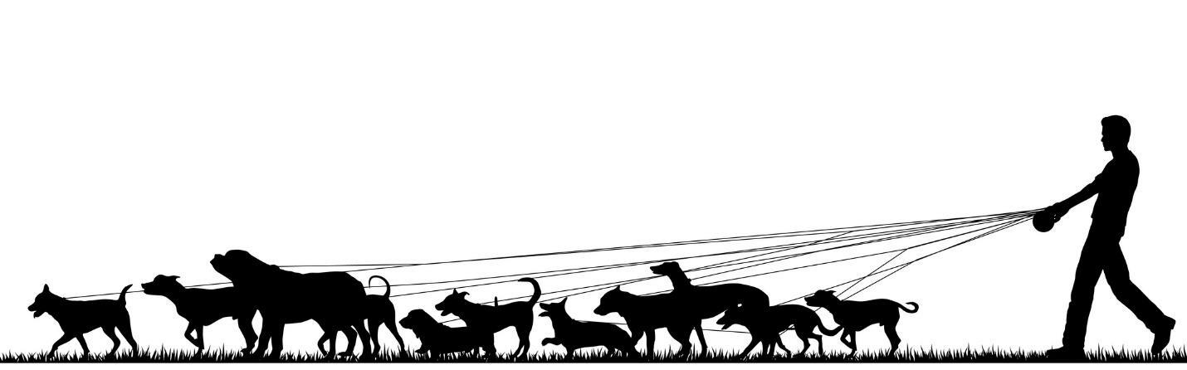

**INSTALLATION**

Please be advised that Microsoft Access version 2016 or later may be required to properly run your database.

Option 1)

Navigate to the location of database files (if removable media such as CD or USB drive were supplied, insert media into appropriate drive and navigate to their default location) and simply double click on the Ad Hoc Innovations – Dog Walker Database.accdb file to open the database.

Option 2)

Navigate to and open Microsoft Access 2016 (or later).

Click on Open Other Files

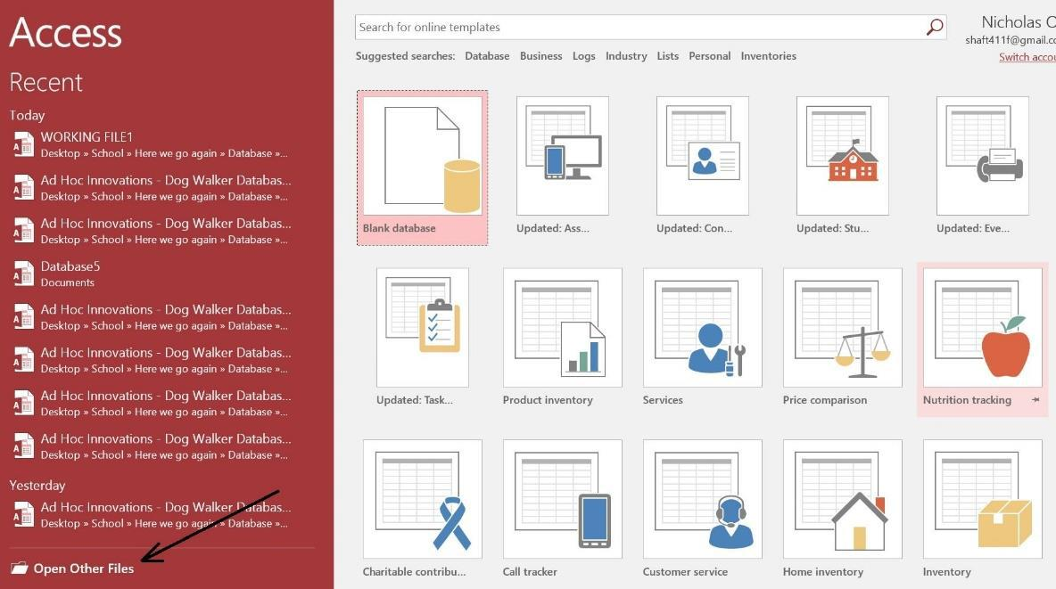

|  |  |
| --- | --- |
| MILESTONE 6 – NOVEMBER 2017 | 30 |

Then navigate to the stored location of your database file and select Ad Hoc Innovations – Dog Walker Database.accdb – you can either double click the file name in the navigation window or single click to highlight the file name and click Open

**NAVIGATION**

Upon opening your database, you will be presented with the Main Menu of your Switchboard.

It is from here that you will be able to perform a variety of actions on your database through a user-friendly graphical interface.

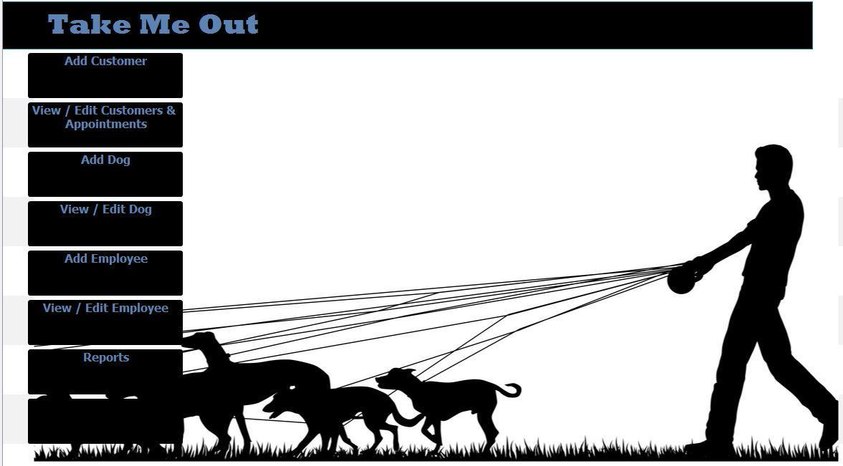

Click on Add Customer to open a form that will allow you to add new customers to your database.

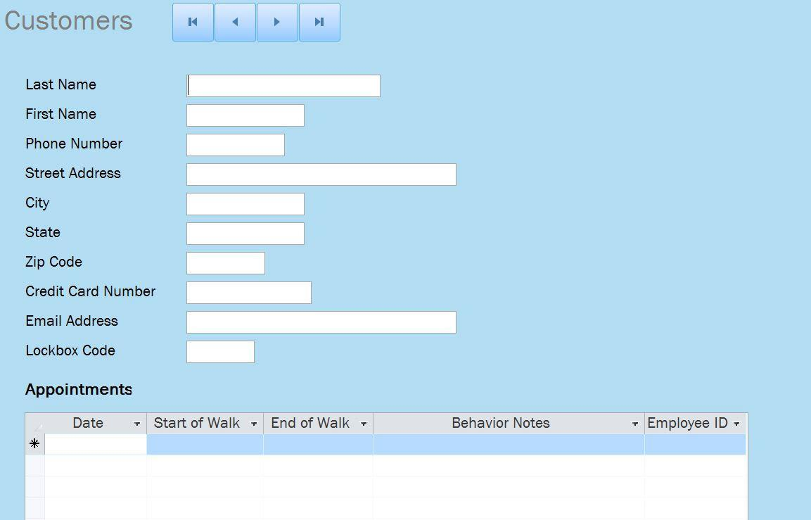

MILESTONE 6 – NOVEMBER 2017 31

You’ll notice some additional buttons displayed at the top of the form – these are for navigation within that form and will allow you to:



Return to

Move back Move forward Proceed to

first record

one record

one record

last record

Click on View / Edit Customers & Appointments if you would like to make changes to current customers and appointments or simply view records.

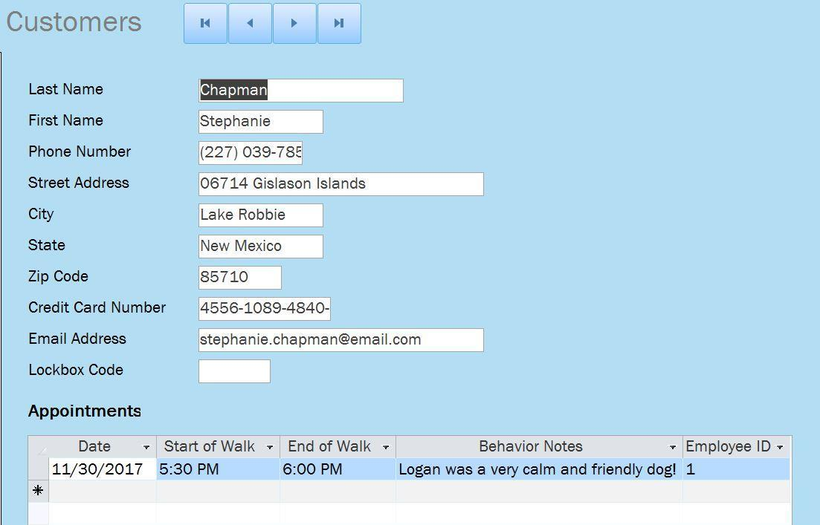

Like the function of the Customer options, there are Dog options as well. Click on Add Dog to assign a new pet to an established customer. Or if you would like to make changes to a current pet, such as updating their special needs, click on View / Edit Dog.

|  |  |
| --- | --- |
| MILESTONE 6 – NOVEMBER 2017 | 32 |

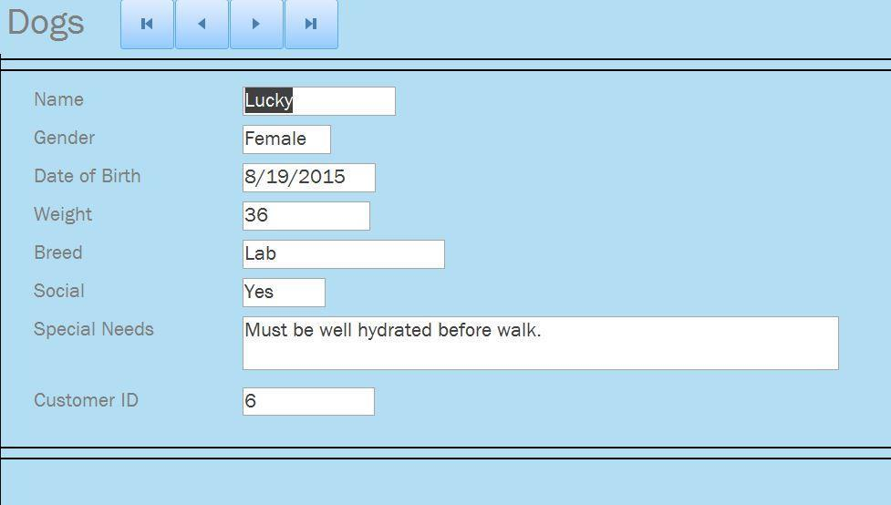

In addition to the Customer and Dog forms available, there are similar Employee forms accessible through the main menu. Click on Add Employee to enter new walker information into the database or click on View / Edit Employee to navigate through current employee records or make adjustments to a certain employee, such as updating their Insured & Bonded status.

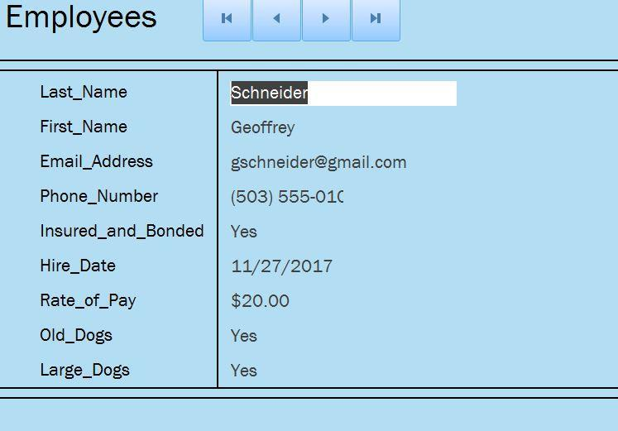

Your new database is not only capable of keeping records up-to-date and easily accessible, but of providing useful, valuable information to you about your business. This information is presented via Reports that you can access through the Switchboard user interface.

|  |  |
| --- | --- |
| MILESTONE 6 – NOVEMBER 2017 | 33 |

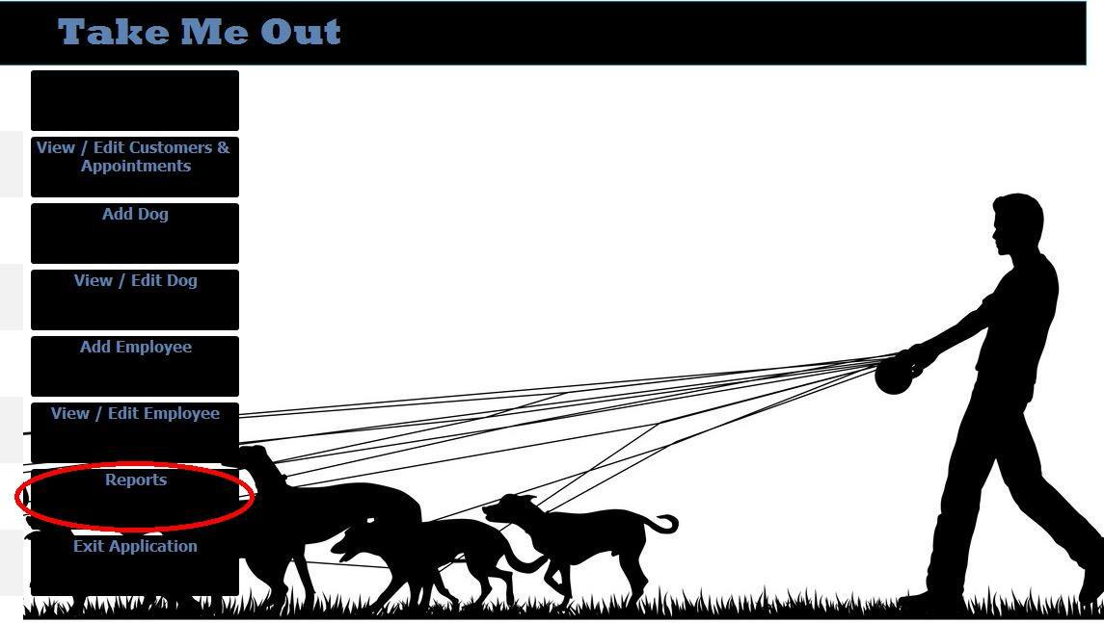

Click on the Reports button to open the Reports menu.

From this menu, you can select a variety of different reports that each provide valuable insight into business trends and beyond. Your database manager will easily be able to update and even add new reports to your switchboard, with minimal overhead.

Click on Main Menu to return to the Main Menu.

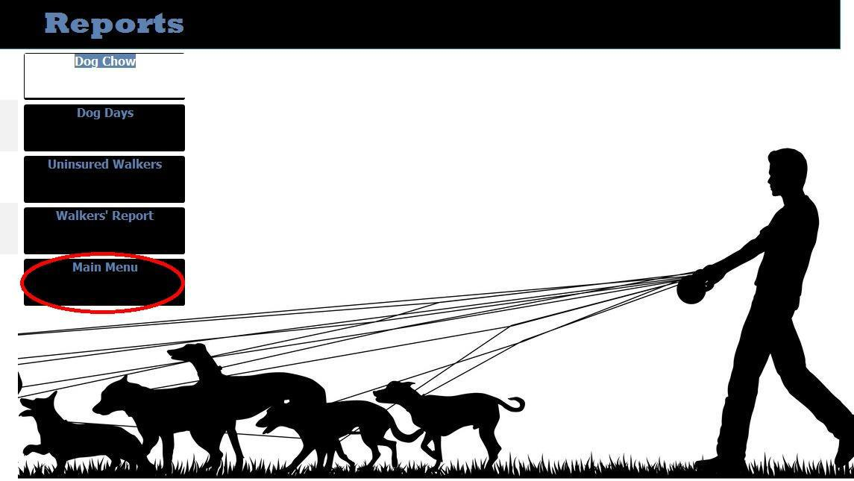

|  |  |
| --- | --- |
| MILESTONE 6 – NOVEMBER 2017 | 34 |

When you are finished working with your database for the time being, simply navigate back to the Main Menu and click on the Exit Application button to close the database.

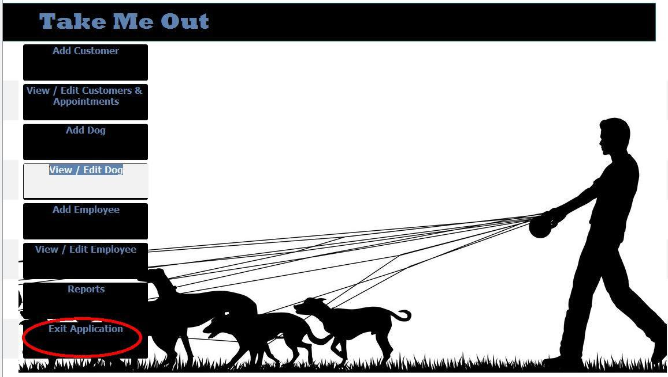

MILESTONE 6 – NOVEMBER 2017 35